STATIC ANALYSIS – EFFICIENCY

*HideUtilityClassConstructorCheck
-Utility classes should not have a public or default constructor: The utility classes (classes that contain only static methods) should not have a public constructor.
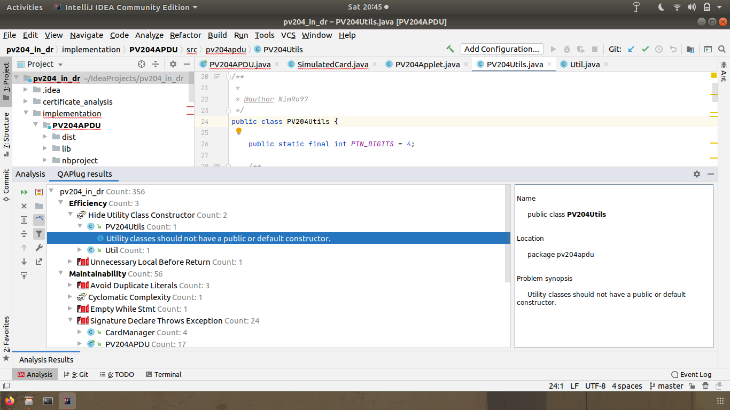

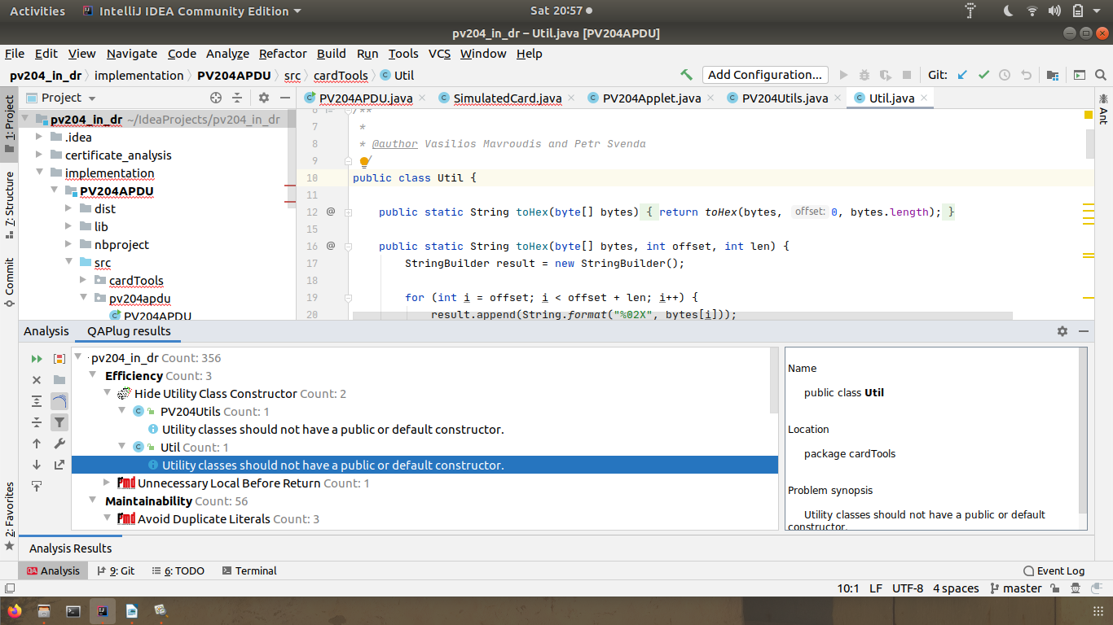
*UnnecessaryLocalBeforeReturn
-Avoid unnecessarily creating local variables
